As per my understanding below is the flow for Dieseltech Application, please review and modify if anything is missing/incomplete

Below is the Definition module with detailed properties/attributes of entities. Kindly mention/modify if there is need of any new definition or any additional properties/attributes required.

1. **Definitions**
   1. **Broker** (Broker Name, MC#, Assign ID, Contact Name, Phone Number, Zone Reference, State Reference, City Reference)
      1. **Broker Helper** (Broker Reference, Broker Helper Name, Zone Reference, State Reference, City Reference)
   2. **Carrier** (Carrier Name**,** MC#, Assign ID, Contact Name, Phone Number, Zone Reference, State Reference, City Reference)
      1. **Carrier Helper** (Carrier Reference, Carrier Helper Name, Zone Reference, State Reference, City Reference)
   3. **Zone** (Zone Id, Zone Name)
      1. **States** (Zone Reference, State Name)
         1. **Cities** (Zone Reference, State Reference, City Name, Zip Code)
   4. **Drivers** (Zone Reference, State Reference, City Reference, Driver Name, Contact Number, Address)
   5. **Truck** (Carrier Reference, Zone Reference, State Reference, City Reference, Truck Number, Contact Person, Equipment Type/Truck Information, Driver Reference, Truck Yard, Trailer#, Language, Address)
   6. **Shipper (**Zone Reference, State Reference, City Reference, Name, Phone, Address**)**

|  |  |  |  |  |
| --- | --- | --- | --- | --- |
| **Country** | **Zone Name** | **State Name** | **City** | **Zip Code** |
| United States | Zone 0 | NH, ME, VT, MA, RI, CT, NJ | (cities will under each state?) | Please mention all zip code as well |
| United States | Zone 1 | NY, PA DE |  |  |
| United States | Zone 2 | SC, VA, NC, WV, MD, DC |  |  |
| United States | Zone 3 | MS, AL, TN, GA, FL |  |  |
| United States | Zone 4 | MI, IN, OH, KY |  |  |
| United States | Zone 5 | MT, ND, SD, MN, IA, WI |  |  |
| United States | Zone 6 | NE, KS, MO, IL |  |  |
| United States | Zone 7 | TX, OK, AR, LA |  |  |
| United States | Zone 8 | NV, ID, UT, WY, CO, AZ, NM |  |  |
| United States | Zone 9 | CA, OR, WA |  |  |

Carrier or Carrier helper can be select for load

**Number to text** is just to save in record or need to send text

1. **Transactions**
   1. **Load**
      1. 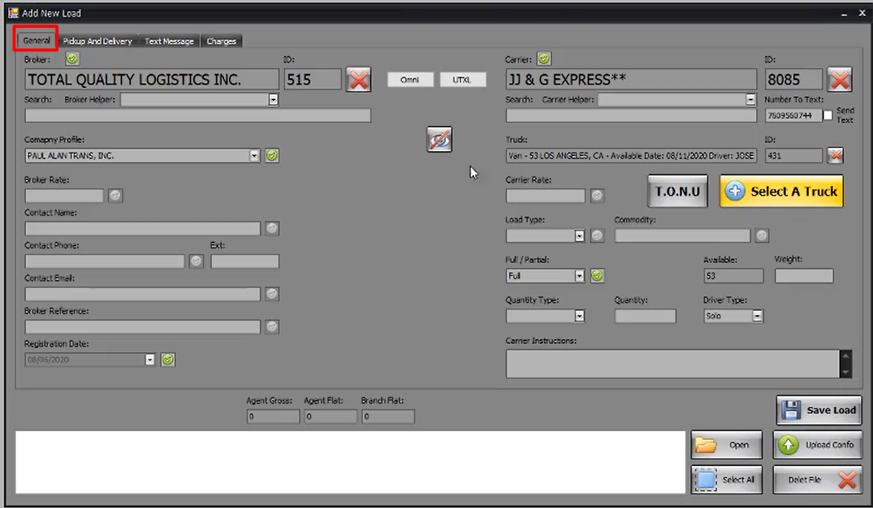**General Information**

Broker or broker helper can be select for load

* + 1. 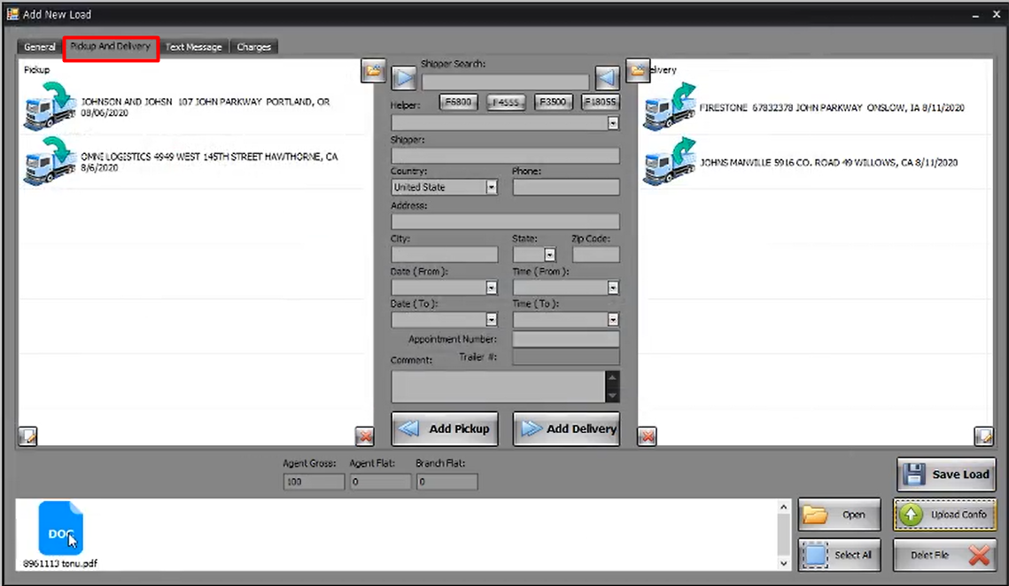**Pickup and Delivery**
    2. **Charges**

Please Explain from where we get **“By”** column data

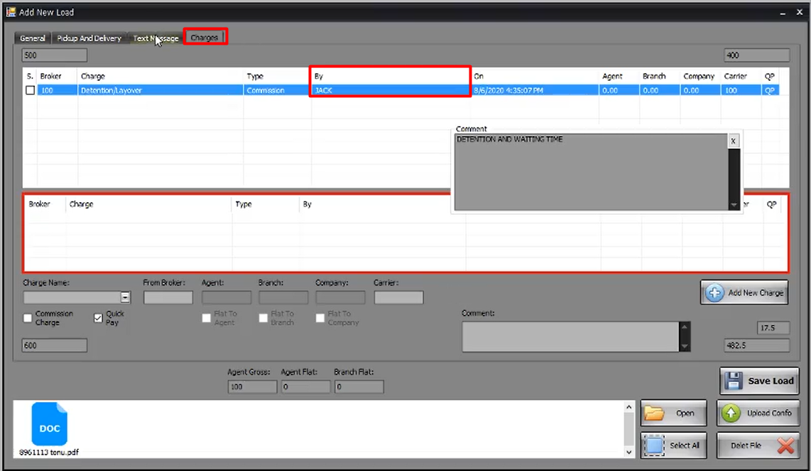

Please explain what is the role of Flat to agent, float to branch, flat to company in amount calculations

Please explain these calculations formula

**The basic flow of a Load:**

**Step#1:** You receive a document for a job to be done from customer/tender provider

**Step#2:** Enter Load details in the Load form and attach job document within that. After the load entry, how will the Broker/Carrier will be informed? And after the job has been started, what step we need to do next after adding load in the system?

**Step#3:** Is the below screen **“Broker Confo”** is the third step and then **“Carrier Confo”**? And all of these confirmations are updated by you or Broker or Carrier will have login for the same?

And what is **“Outside Conformation Print”**?

How **“Payment Breakdown”** works? Please explain it’s business flow as well.

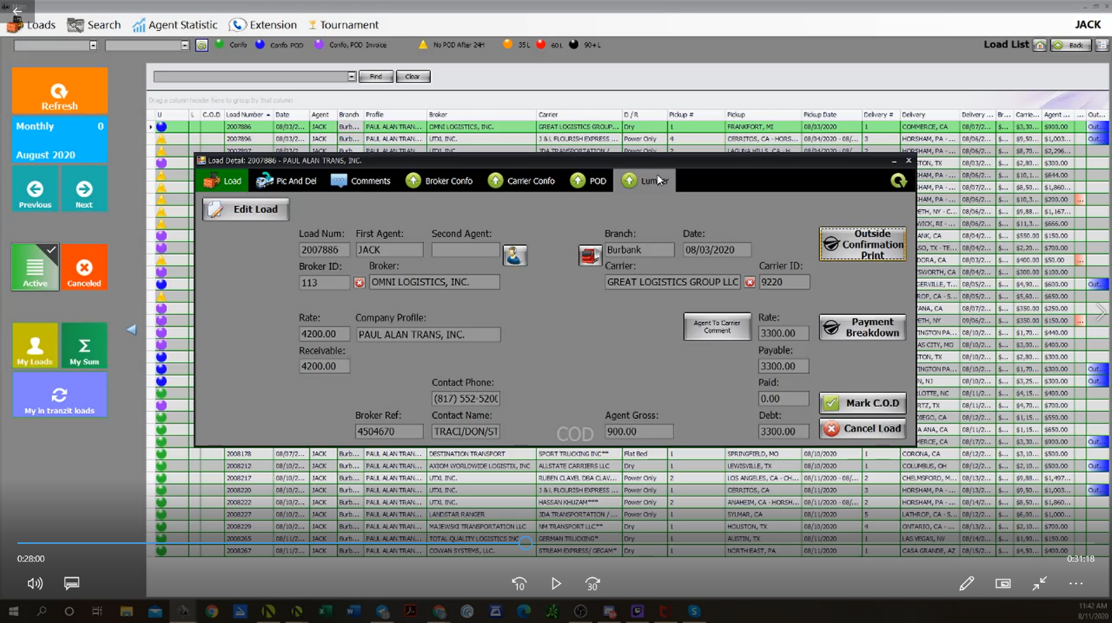

Please explain from where the **Branch** shown in load. What is relation with Load or Broker/Carrier?

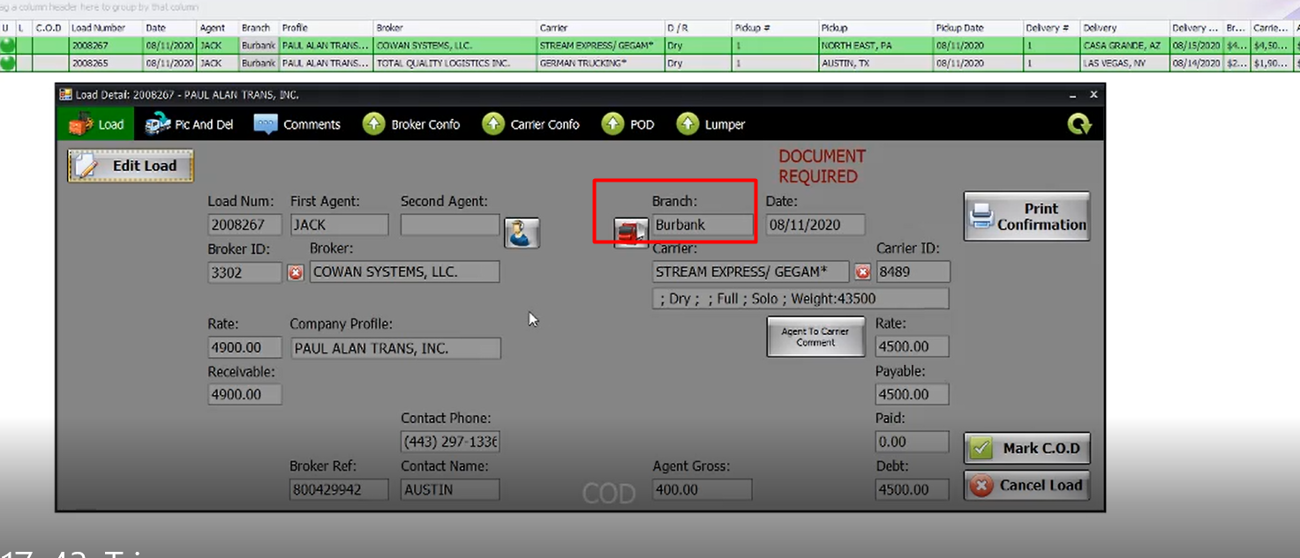

From where the **Dispatcher (name, email, Cellphone)** information is coming for a load Preview? Who is entering? Or to which entity it is linked with?

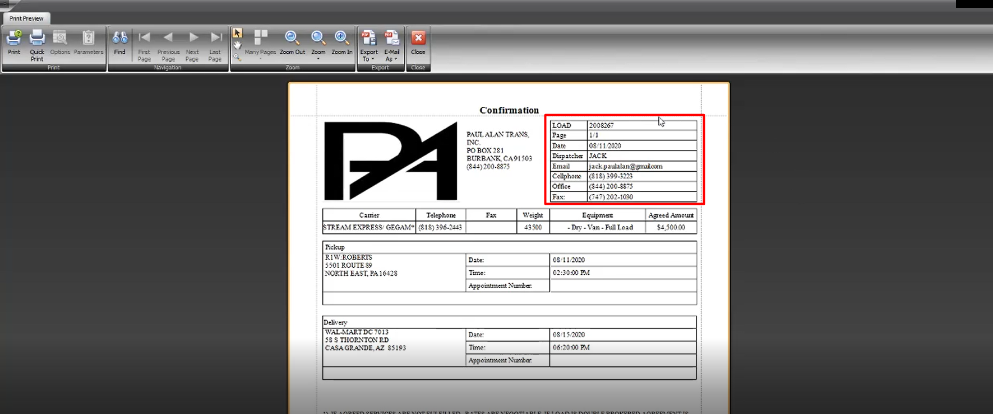

Please explain “**Credit Check”**, which credits are being checked? How these are being available in the balance of the Broker?

Company profile means, if we have multiple companies to select one in which Load job is assigned?

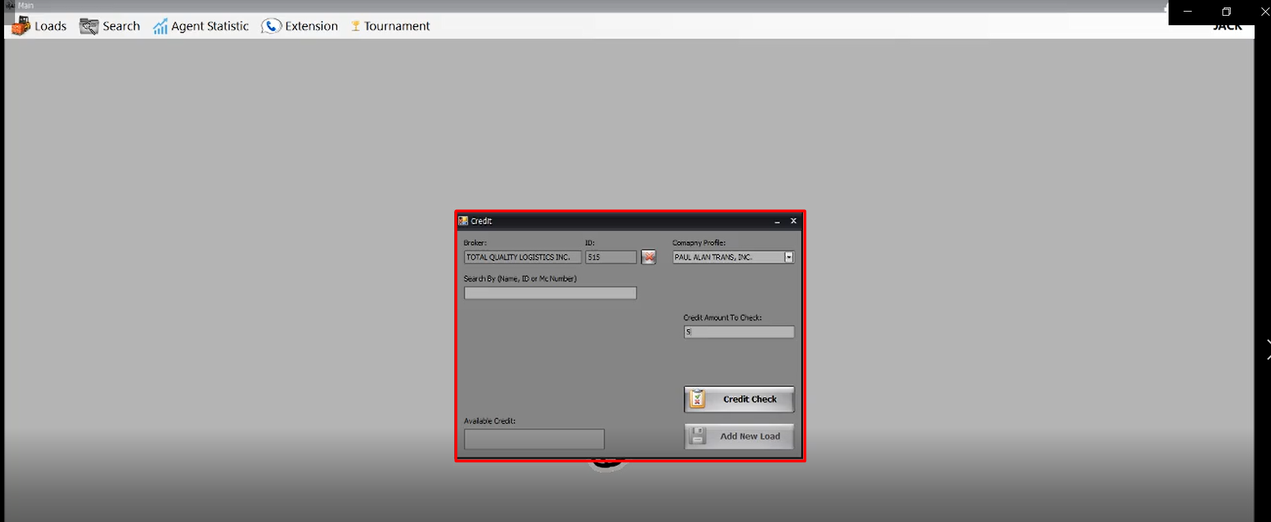

**Dashboard** (Dashboard contains list of trucks that can be filtered daily , weekly ,month)

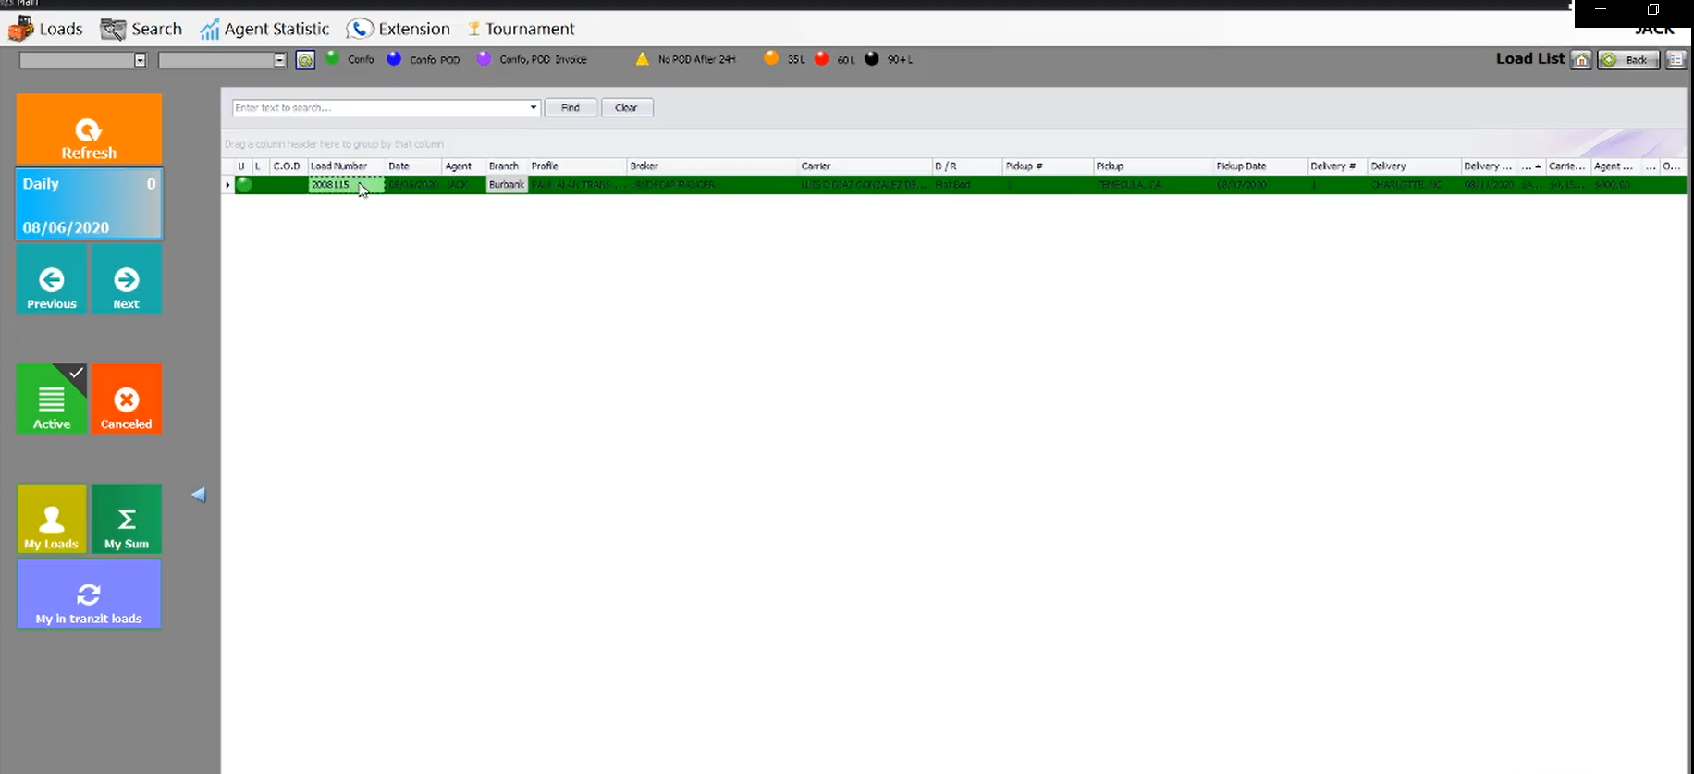

**Trucks List**

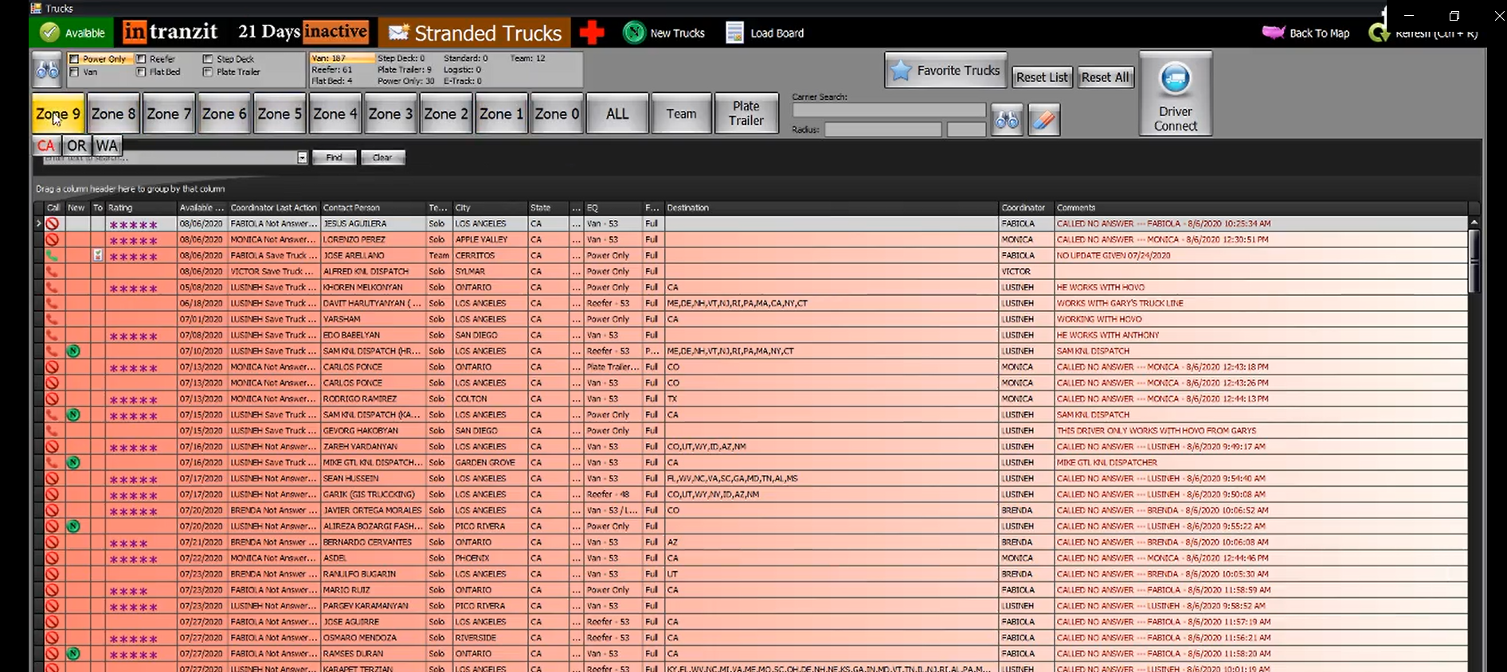

Please Explain “**Call**” column.